**Traffic Control System**

**Abstract**

The human population in cities is increasing day by day and therefore number of vehicles is increasing exponentially. Traffic control signals have been playing significant role in managing traffic flow in cities. But the conventional traffic control signals fails in time management. It allocates equal time slots to each road irrespective of the traffic density. This creates unnecessary waiting for drivers, which is not possible every time. Therefore, we propose density based traffic control system, which allocates different time slots to each road according to vehicle density. The vehicle density is measured in three zones low, medium and high. The traffic density in each lane is measured using IR sensors. Accordingly the traffic signal lights give the green light based on the vehicle density. This requires development of a system to handle traffic in a smart way by automatically adjusting its timing based on traffic density using Arduino Nano ATMega328P. In this, traffic is sense using digital IR Sensors and IR Sensors detect vehicles further based on the signal reflected from them. Sensors placed adjacent to the road to control the traffic density by changing traffic signal appropriately. All IR Sensors are interfaced with Arduino Nano and it reads data from IR Sensors. Traffic Signal for the system is designed using LEDs. Using this system development at traffic junction we need not to worry about handing the traffic manually and also consumes less time as compared to the conventional traffic system.

**Introduction:**

In present day scenario the problem of traffic congestion is becoming more serious day by day. As population increases continuously so does the number of vehicles. The underdeveloped infrastructure and inadequate distribution of development are inflicting various problems. Smart traffic light signals are required to cut back the traffic delay and travel times more importantly in developing countries. As current traffic systems are handled manually or using fixed timing systems. So we need smart and fast robust traffic handling systems. The lane on a junction which has additional number of vehicles the traffic light is made green and red for the rest sides until traffic on that lane is cleared. This would help in smooth movement of traffic and also increase comfort and driving safety of the travelers. With increase in number and variety of automobile on road, heavy traffic congestions are drastically increasing in major cities. This happens typically at the most junctions commonly during office hours and in the evenings, post office hours, when office people travel to home. The foremost effect of this situation is the increase in time wastage of the people on the road. The solution for this problem is coming with a totally different program with different delay settings for various junctions. At some junctions, generally even in the absence of jam packed traffic, people are compelled to wait. Since the traffic signals remain red for the set period of time, the road user has to wait till the lights turn to green. If they cross the road when the light is red, they are needed to pay fine. The answer to this drawback is coming up with a program that analyses traffic direction on every road and sets temporal order of signals accordingly. Also, time agreements of traffic signals in various junctions are additionally required. The proposed smart density based traffic light system handles the issues in very efficient way. In this, traffic is sense using digital IR Sensors and IR Sensors detect vehicles further based on the signal reflected from them. Sensors placed adjacent to the road to control the traffic density by changing traffic signal appropriately. All IR Sensors are interfaced with Arduino Nano and it reads data from IR Sensors. Traffic Signal for the system is designed using LEDs.

**Objectives:**

* In this, traffic is sense using digital IR Sensors and IR Sensors detect vehicles further based on the signal reflected from them.
* Sensors placed adjacent to the road to control the traffic density by changing traffic signal appropriately.
* All IR Sensors are interfaced with Arduino Nano and it reads data from IR Sensors. Traffic Signal for the system is designed using LEDs. Using this system development at traffic junction we need not to worry about handing the traffic manually and also consumes less time as compared to the conventional traffic system.

**Problem Definition:**

In today's life we have to face many problems, one of which being traffic congestion and it's becoming more serious day after day. Conventional traffic system does not have proper monitoring system and often requires manual handing at traffic junction. This not only causes mental stress in passengers but also lot of fuel goes wasted due to delay at traffic junction.

**Proposed System:**

The smart traffic control system is meant to manage the traffic signals based on the traffic density of the lane. It's designed to sense traffic, manage the traffic based on density by operating the traffic signals appropriately. The traffic is sensed using digital IR sensors. The IR sensors detect vehicles based on the light reflected from them. They are placed adjacent to the road and facing the lane, so that they can detect the traffic. Also, we will place them at a significant distance from the junction such that they detect stagnant traffic only after a threshold is reached. Basic block diagram is shown in Fig. The Arduino Nano which acts as the brain of the system will read data continuously from the IR sensors. It will determine the traffic density depending on the information received from the sensors, based on the traffic density of every lane it will control the traffic signals which will then use the stagnation of traffic. The traffic signals for the system are designed using LEDs. Each signal has two LEDs, one red and one green. We will design a traffic control system for a four lane junction. There will four digital IR sensors, one for each lane and there will 8 LEDs which act as the traffic signals for each of the lanes. Each digital IR sensor has four terminals, the digital out pins of the sensors are connected to the digital pins 8-11 of the Arduino Nano. These will be used to read data from the IR sensors. The analog pins are left unconnected. Whereas the Vcc and ground pins are connected to the power supply. The cathode pins of all the LEDs are connected to the common ground of the traffic control system. The anodes of the LEDs are used to send the signal and switch them ON/OFF. The anodes of all the LEDs are connected to digital pins of the Arduino Nano which is essentially the port D of the board.

**Block Diagram:**

Power Supply

Signal 1

**ATMega 328P**

IR Sensor 1

Signal 2

IR Sensor 2

Signal 3

IR Sensor 3

Signal 4

IR Sensor 4

**Literature Survey:**

**R.Bhargav Devi, E.Sravani, Gaddam Srujan**, et.al [1] system uses counter mechanism to find the number of vehicles on each lane which leads to processing overhead. In the proposed system the total of vehicles on each lane is estimated and state (ON/OFF) of LEDs change accordingly hence program flow is simpler and processing overhead is reduced.

The author **Zhang Yuye** et.al. [2] system utilise AT89C1 in which power requirement is more and also there is no inbuilt ADC but the proposed system uses ATMega 328 microcontroller which consumes lesser power and also has inbuilt ADC.

The author **Koushik Mandal, Arindam Sen** et.al. [3] system uses congestion detection algorithm by computation of transport speed over a section of road and also the average waiting time of motor vehicles at the road crossings which leads to complexity. The proposed system does congestion detection using IR sensor which reduces complexity.

The author **I.Jasmine** et.al.[4] proposed a system wherein the functioning is the very close to our proposed system but the system also includes emergency vehicle detection for which RFID, LCD display and buzzer are also used which increase system complexity and cost. Our proposed system also uses solar energy which makes it environment friendly.

The author **Shilpa S.Chavan** et.al.[5] design of traffic signal controller handle issues of the standard traffic signal. At certain junctions, sometimes although there's no traffic, individuals need to wait since the traffic signal remains red for the predetermined time and road user wait till the light remains red and turns to green. They have tried to resolve this downside effectively by using GSM however this will lead to complications. The projected smart density based traffic light system resolves this problem by utilizing IR sensors.

**Hardware and Software Requirements:**

**Hardware:**

1. Arduino Nano
2. IR sensors
3. Traffic Signal LED’s
4. Power supply

**Software:**

1. Arduino IDE
2. Embedded C

**Hardware Description:**

**Arduino Nano**

The Arduino Nano is a small, complete, and breadboard-friendly board based on the ATmega328.  It lacks only a DC power jack, and works with a Mini-B USB cable instead of a standard one.

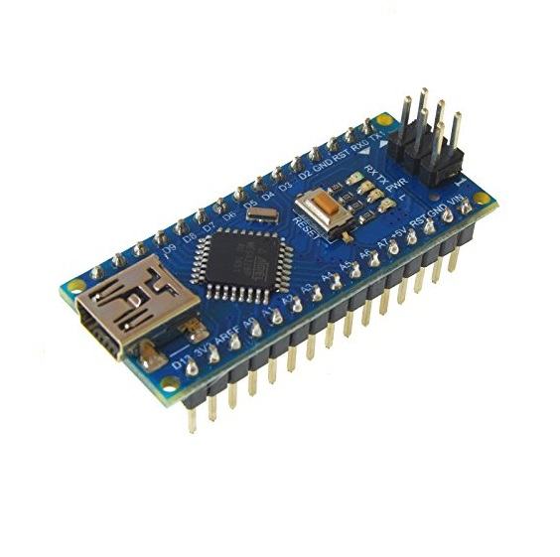

**Technical Specifications:**

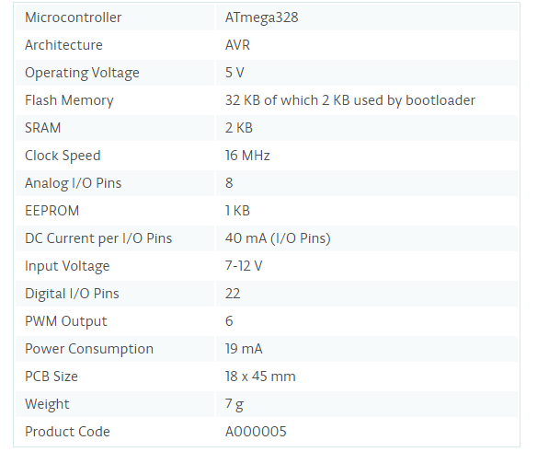

**Applications**

* Prototyping of Electronics Products and Systems
* Multiple DIY Projects.
* Easy to use for beginner level DIYers and makers.
* Projects requiring Multiple I/O interfaces and communications.

**IR Sensor**

IR Sensor module has great adaptive capability of the ambient light, having a pair of infrared transmitter and the receiver tube, the infrared emitting tube to emit a certain frequency, encounters an obstacle detection direction (reflecting surface), infrared reflected back to the receiver tube receiving, after a comparator circuit processing, the green LED lights up, while the signal output will output digital signal (a low-level signal), through the potentiometer knob to adjust the detection distance, the effective distance range 2 ~ 10cm working voltage of 3.3V-5V. The detection range of the sensor can be adjusted by the potentiometer, with little interference, easy to assemble, easy to use features, can be widely used robot obstacle avoidance, obstacle avoidance car assembly line count and black-and-white line tracking and many other occasions.

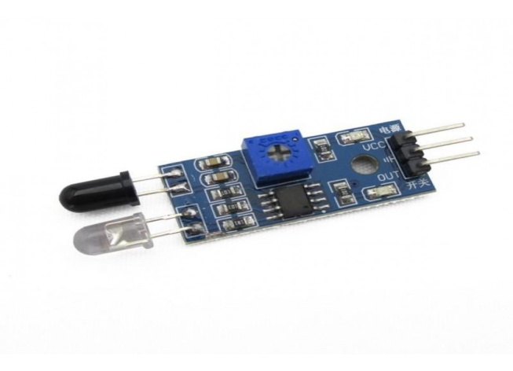

**Red LED**

It is a 3mm Red DIP LED. An LED is a two-lead semiconductor light source, which emits lights when activated. When an appropriate voltage is applied to the LED terminal, then the electrons are able to recombine with the electron holes within the device and release energy in the form of photons. This effect is known as electroluminescence. The color of the LED is determined by the energy band gap of the semiconductor.

#### ****Features:****

* 3mm Round Water Clear LED Lamp
* For LED light, indication, illumination
* Viewing angle: 40 degree
* UV resistant epoxy
* With lowest power consumption, long life, and super bright

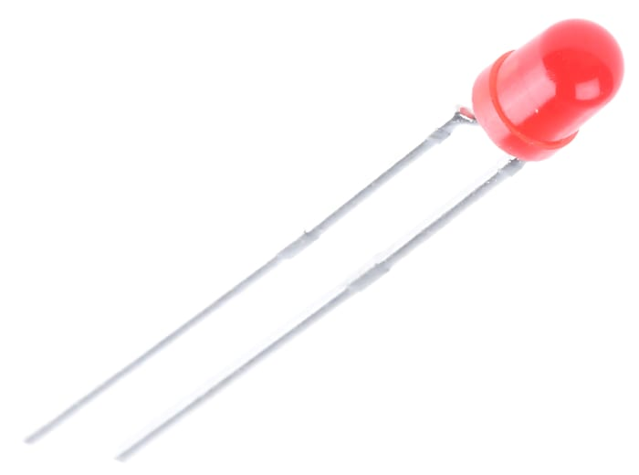

**Green LED**

A  Green light-emitting diode (LED) is a semiconductor light source. LEDs are used as indicator lamps in many devices and are increasingly used for lighting. It looks like a Green led and it illuminate Green light. The series is specially designed for applications requiring higher brightness. The led lamps are available in different colors, intensities.

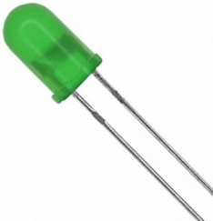

They are used in a wide range of Application such as

* TV set
* Monitor
* Telephone
* Computer
* Project Panel for Indicators

#### **Features:**

* Choice of various viewing angles
* Available on tape and reel
* Reliable and robust
* Pb free
* The product itself will remain within RoHS compliant version Applications

**Software:**

**Embedded C**

The embedded c programming language is used in the microcontrollers. The embedded c language is a general-purpose programming language that provides code efficiency, elements of structured programming and a rich set of operators. Embedded c is not a big language and is not designed for any one particular area of application. It’s generally combined with its absence of restriction, makes embedded c a convenient and effective programming solution for a wide variety of software tasks. Many applications can be solved more easily and efficiently with embedded c than with other more specialized languages.The embedded c language on its own is not capable of performing operations (such as input and output) that would normally require intervention from the operating system. Instead, these capabilities are provided as a part of standard library. Because these functions are separated from the language itself, embedded c is especially suited for producing code that is portable across wide platforms.

**Arduino IDE**

Arduino is an open-source electronics platform based on easy-to-use hardware and software. Arduino boards are able to read inputs - light on a sensor, a finger on a button, or a Twitter message - and turn it into an output - activating a motor, turning on an LED, publishing something online. You can tell your board what to do by sending a set of instructions to the microcontroller on the board. To do so you use the Arduino programming language (based on Wiring), and the Arduino Software (IDE), based on Processing.

**Reference:**

1. R.Bhargav Devi, E.Sravani,Gaddam Srujan, Shiv Shankar “Density Based Traffic Signal System using Arduino Nano” International Conference on Inventive Computing and Informatics (ICICI) 2017.
2. Zhang Yuye & Yan Weisheng, (2009) “Research of Traffic Signal Light Intelligent Control System Based On Microcontroller”, First International Workshop on Education Technology and Computer Science,pp301- 303.
3. Kaushik Mandal, Arindam Sen, Abhijnan Chakraborty and Siuli Roy “Road Traffic Congestion Monitoring & measurement using RFID & GSM Technology” , IEEE/Annual Conference on Intelligent Tranportation System, 2011.
4. J. Jasmine, Deva Priya, G. Ram Swathi, P. Nathiyar "Intelligent Traffic Control System Using Arduino Nano" IJEAIS Vol. 3 Issue 3, March – 2019, pp. 51-56.
5. Shilpa S. Chavan, Dr. R. S. Deshpande & J. G. Rana (2009) “Design of Intelligent Traffic Light Controller Using Embedded System” Second International Conference on Emerging Trends in Engineering and Technology, 2009, pp1086- 1091.